Using the Consumption Writer plug-in

This plug-in to EwE 6.5 and newer writes Ecosim consumption data to CSV file when Ecosim runs, and when explicitly activated. To activate, navigate either to the EwE file management settings (Menu > Tools > Options > File Management, Figure 1) or to the configuration interface of the plug-in itself (Menu > Tools, Figure 2), and turn on the auto-save option.
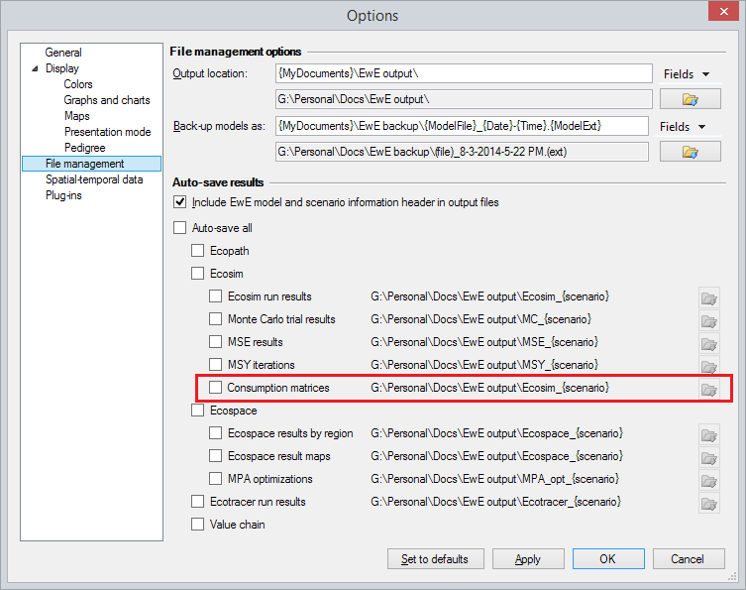
Figure 1 - Activating automatic saving of Ecosim consumption matrices
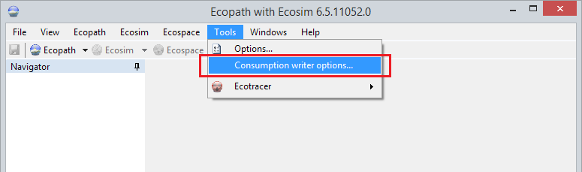
Figure 2 - Activating the consumption writer plug-in settings
The consumption writer plug-in offers a few options to customize what is written to disk (Figure 3): (i) enabling or disabling generation of Ecosim consumption matrix csv files; (ii) including detritus groups in the square consumption matrices; and (iii) including diet imports and total consumption sums (per group).

Figure 3 - Options for the consumption writer

